Fourth Song
Excerpt from Dark Elegies (1937)
Choreography: Antony Tudor
Labanotation score: Airi Hynninen, 1980
Music by: Gustav Mahler: Kindertotenlieder
Costumes: Sandra Legg, OSU Dep’t of Dance Costume Stock, after the designs of Nadia Benois
Lighting Design: David Covey
Staging: John Giffin and Karena Birk

Karena Birk

Katherine Brock, Eran Hanlon, Daniel Holt, Lindsay LaPointe, Bridget Mundy, Teoma Naccatato, Eric Nordstrom, Rodney Veal

~ INTERMISSION ~

Artemis and Aphrodite in the Garden of Give and Take (2010)
Choreography: Melanie Bales
Music by: François Couperin, Jean-Baptiste Lully
Costumes: Jolene Bartley, Karena Birk, Class Act Tutu
Lighting Design: Carrie Cox

Jolene Bartley and Karena Birk
~

Simple Shape (2010)
Choreography: Lily Skove
Music by: The Chandeliers
Costumes: Lily Skove
Lighting Design: Lily Skove

Erik Abbott-Main, Dante Brown, Katy Gilmore,
Teoma Naccarato, Danielle Meier, Amanda Platt,
Maree Remalia
~

Persistence of Memory (2010)*
Choreography: Rodney Veal
Music by: Tosca, MC. Solaar, Thom Yorke, Nas, Sheila Chandra
Costume Concept: Rodney Veal
Lighting Design: Rodney Veal

Erik Abbott-Main, Katherine Brock, Lindsay Caddle LaPointe, Jasmine Marlow, Bridget Mundy,
Michelle Reid

*Part one of two. Part two at Urban Arts Space, March 18-April 2
~ Production Staff ~

Production Managers: David Covey and Carrie Cox
Production Graduate Associate: Teoma Naccarato
Stage Manager: Brittany Strine
Technical Crew: Melanie Gallo and students of Dance Production 298
House Manager: Lily Skove
Box Office: Luis Calvillo, Frederick Rosaria Flecha
Program Design: Karena Birk
Poster Design: Rodney Veal
Videographers: James Graham and students of Dance Video Documentation 661

Susan Petry Chair, Department of Dance
John W. Roberts Interim Dean, College of the Arts and Humanities
Joseph E. Steinmetz Executive Dean, College of the Arts and Sciences

The OSU Department of Dance is an accredited member of the National Association of Schools in Dance (NASD). The department also maintains annual membership with the following national and international organizations: Dance/USA, American College Dance Festival Association (ACDFA), Body/Mind Centering Association (BMCA), Council of Dance Administrators (CODA), Association of Performing Arts Presenters (APAP), National Dance Education Organization (NDEO), OhioDance, and Ohio Alliance for Arts Education (OAAE). The department is proud to annually send students to the International Association of Blacks in Dance (IABD) Conference and to a regional American College Dance Festival (ACDF).

 | OSUDance  614-292-7977  www.dance.osu.edu

We appreciate your attention and action to these items for the safety and consideration of the performers and other audience members:
*Please turn off all cellular telephones, pagers, and other electronic devices.
*No picture taking of any kind or flash photography is allowed.
*No unauthorized use of recording devices.
*No smoking in the building. The State of Ohio Smoking Ban of 2006 information is posted on the building’s external doors.
*Please keep talking and rustling of papers or notebooks to a minimum.

The Ohio State University Department of Dance presents
Winter Perspective

The MFA concert of
Jolene Bartley, Karena Birk, Lily Skove, Rodney Veal

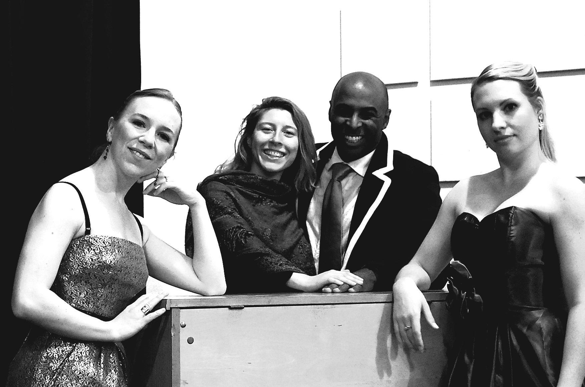

Choreography by
Melanie Bales Senta Driver Fanny Elssler
Lily Skove Antony Tudor Rodney Veal

Sullivant Theatre
1813 N High Street

Thursday, Saturday, Sunday
February 11, 13, 14, 2010
8:00pm Thursday and Saturday
2:00pm Sunday

La Cracovienne (1839)
Choreography: Fanny Elssler, after traditional
Polish military dances
Reconstruction: Knud Arne Jürgensen, from August Bournonville’s 1842 notes.
Labanotation score: Ann Hutchinson Guest
Music by: Józef Damse and Karol Kurpinski after
Polish folk tunes
Costume: Marilyn Bartley, Jolene Bartley, Class Act Tutu
Lighting Design: Carrie Cox
Staging from Labanotation score: Jolene Bartley

Jolene Bartley

Susan Chess, Piano

~

La Cachucha (1836)
Choreography: Fanny Elssler, after traditional Spanish dances
Reconstruction: Friedrich Albert Zorn, 1887
Labanotation score: Ann Hutchinson Guest, 1981
Music: Traditional folk tune
Costume: Karena Birk, Mary Yaw McMullen, Class Act Tutu
Lighting Design: Carrie Cox
Staging from Labanotation score: Valarie Williams and Karena Birk

Karena Birk

Susan Chess, Piano

~

“Drink To Me Only With Thine Eyes”
Excerpt from Missing Persons (1981)
Choreography: Senta Driver
Music: "Drink To Me Only With Thine Eyes" performed by Forbes Robinson and "Drink To Me Only With Thine Eyes" performed by Janet Baker
Costumes: Marilyn Bartley, Jolene Bartley
Lighting Design: David Covey
Staging: Susan Hadley and Jolene Bartley

Jolene Bartley

Erik Abbott-Main, Danté Brown,
Katy Gilmore, Amanda Platt

~
~ About the Historical Works ~

Fanny Elssler (1810-1884) was one of the preeminent ballerinas of the Romantic era, famed for her passionate, earthy, and energetic dancing. In an era when the light, airy, ethereal qualities of her rival, Marie Taglioni, were becoming the standards by which dancers were judged, Elssler’s immense popularity helped establish a contrasting strain in Romantic ballet, earthy versus ethereal. These dual, contrasting elements contained in Romantic ballet became one of its greatest strengths. The solos La Cracovienne and La Cachucha are two solos for which she was famous, and which she performed throughout the world.

Performance of La Cracovienne was made possible by the generosity of Knud Arne Jürgensen and Ann Hutchinson Guest and by support from the OSU Department of Dance’s Quarterly Funding Initiative.

Coached by Professors Karen Eliot, Sheila Marion, and Valarie Williams.

Performance of La Cachucha was made possibly by the generosity of Ann Hutchinson Guest, by support from an Alumni Grant for Graduate Research and Scholarship, and by support from the OSU Department of Dance’s Quarterly Funding Initiative.

Coached by Professors Valarie Williams and Karen Eliot.

Senta Driver (1942-) is a renowned American dancer and choreographer of the late 20th century. She discovered dance while in college at Bryn Mawr, where she received her BA in Latin and Philosophy. In 1966, Ms. Driver received her Master’s degree from The Ohio State University. Following graduation, Ms. Driver joined the Paul Taylor Dance Company. She then created her own New York City based company, Harry, in 1975. Ms. Driver is cited as choreographing works full of powerful physicality and intelligence, along with dealing with issues of weight and gender equality. Ms. Driver originally choreographed Missing Persons, a piece about death, for Harry in 1981.

“Drink To Me Only With Thine Eyes,” excerpt from Missing Persons Staged by Jolene Bartley and Susan Hadley, from the Labanotation score notated by Mary Corey, 1981-82, by arrangement with the Dance Notation Bureau who has preserved, enriched, and furthered the art of dance for 70 years, 1940-2010.

Performance of this excerpt was made possible by the generosity of Ms. Senta Driver and support from the Dance Preservation Fund.

Coached by Professor Susan Hadley.

Antony Tudor (1908-1987) was one of the greatest 20th century ballet choreographers. He is widely credited with establishing psychological realism in ballet. Dark Elegies is one of his early and enduring masterpieces. Its dark subject matter—the portrayal of a community in mourning—and its stark, non-balletic movement style were unusual at the time, and signaled a new era in dance.

Fourth Song, excerpt from Dark Elegies, was staged by John Giffin and Karena Birk, from the Labanotation score notated by Airi Hynninen, 1980, by arrangement with the Dance Notation Bureau who has preserved, enriched, and furthered the art of dance for 70 years, 1940-2010. This season's performance of Fourth Song from Dark Elegies, copyright 1983 Antony Tudor, presented by arrangement with The Antony Tudor Ballet Trust, proudly salutes the artistry, vision, enduring relevance of Antony Tudor's work and commemorates the Centennial of his birth, 1908-2008.

Performance of this excerpt was made possibly by the generosity of Sally Bliss and The Antony Tudor Ballet Trust, and by support from an Alumni Grant for Graduate Research and Scholarship.

Coached by Professor Emeritus John Giffin, with additional coaching by Professor Karen Eliot, and Willy Shives, Ballet Master, Joffrey Ballet.

Labanotation is a symbol-based language used to analyze, describe, and document movement. For 70 years, the Dance Notation Bureau has committed itself specifically to the preservation of dance. Labanotation scores, in the form of manuscripts, preserve not only the choreographic work but vital directorial and production information as well. To learn more about Labanotation, please visit the Dance Notataion Bureau, Inc, at www.dancenotation.org
~ Who We Are ~

Jolene Bartley is originally from Sligo, PA. Currently a third-year MFA candidate in Dance at The Ohio State University, she is also a Graduate Teaching Associate and has taught various OSU elective courses including Ballet, Pointe, Jazz, and Hip Hop. In 2006, Jolene graduated from The Pennsylvania State University with a degree in Philosophy and minors in Dance, International Studies, and Classics and Ancient Mediterranean Studies. While at PSU, she also studied abroad in Greece. Jolene then went on to teach dance at The Grier School, a private boarding school for girls in Tyrone, PA, before coming to OSU. She has studied and taught dance within numerous studios and programs; much of her early training took place at Dancer’s Studio, Clarion, PA. She is happy to be part of the world of dance for it is where her passion in life has always resided. Upon graduation this June 2010, Jolene hopes to pursue her dancing and teaching career in Chicago, IL.

Karena Birk, from Seattle, WA, is currently in her third and final year of working towards her MFA in Dance at The Ohio State University. As part of her graduate degree at OSU, she is a Graduate Teaching Associate, teaching ballet and pointe to dance majors and non-majors. Additionally, she serves as the Graduate Student Representative on the Graduate Studies Committee. She received her dance training at Cornish Preparatory Dance Department, the University of Washington, and the Richmond Ballet. She has performed for Lehua Dance Theatre, the Colorado Ballet, Redd Legg Dance, and ARC Dance. Karena has taught on faculty at Bainbridge Dance Center, Cornish, other studios in the Seattle area, and at the Interlochen Arts Camp in Michigan. In 2001, she graduated summa cum laude from the University of Washington with a degree in Classics.

Lily Skove is currently pursuing her MFA in dance and technology at the Ohio State University. Skove and her company, Skoveworks, have been presented at the Time To Dance International Contemporary Dance Festival in Riga, Latvia, at The Chocolate Factory Theater, Movement Research, Chashama, and Galapagos Arts Space in New York City, and at the Governor's Institute in Vermont. Skove has screened her dance films at Dance Theater Workshop in New York City, at Schubas in Chicago, and at the Wexner Center in Columbus for the Ohio Short Film and Video Showcase. Skove holds a Diploma in Dance Studies from the Laban Centre, UK and a B.A. from Wesleyan University.

Rodney Veal a former dancer and Resident Choreographer with Gem City Ballet, serves as adjunct faculty for both Stivers School of the Performing Arts and Sinclair Community College. He is a graduate of Eastern Michigan University with a B.S in Political Science and Visual Arts. He currently attends The Ohio State University where he is entering his third and final year as M.F.A. Candidate in Choreography. He serves as the Chief of Staff to the Council of Graduate Students President and was recently appointed to the Faculty/Student Senate representing the Fine Arts Graduate Students. He currently serves on the Board of Trustees of Ohio Dance and Blue Sky Dayton Project. Mr. Veal is the recipient of several MCACD grants and fellowships. Several of his works have been performed as a part of the Ohio Dance Festival. Mr. Veal was one of twenty-six dancers chosen to participate in the William Forsythe workshop and Choreographic Objects Symposium conducted in collaboration with The Ohio State University Dance department and the Wexner Center for the Arts. He was one of five artists chosen nationwide to participate in the Blue Sky Dayton Project Artist in Residency Program held in collaboration with the University of Dayton in the summer of 2009.

Melanie Bales, Professor, OSU Department of Dance, received her MFA from the University of Illinois, where she also served as a Visiting Assistant Professor, choreographing, performing and teaching both ballet and modern technique. She performed both classical and operetta repertoire in West Germany, and also danced principal duet roles with Douglas Nielsen Dance, New York. Her choreography has received several state and national awards. Ms. Bales has received support to commission dances for performance from choreographers including John Giffin, Iréne Hultman, Daniel Nagrin, Tere O'Connor and Catherine Turocy. In 1999, she and colleague Nicole Stanton presented an evening of works at the Wexner Center Performance Space, and she has choreographed several pieces for OSU Dance Downtown. At OSU, she teaches ballet technique and Laban studies. Her recent book The Body Eclectic (2007) examines training practices in the post-Judson era.
Susan Chess received her Bachelor of Music Education, Master of Arts Degree, and Ph.D in Music Education from The Ohio State University. Her graduate studies included work in music technology, harpsichord, composition and piano. Ms. Chess has played master classes for The Martha Graham Company, Dance Theater of Harlem, Columbus Ballet Metropolitan, Merce Cunningham Company, Bebe Miller, Mark Morris, the Bolshoi and the Kirov Ballet Company and many more. In addition to supervising dance musicians, teaching Dalcroze Eurhythmics, and playing for technique classes in the OSU Department of Dance, Ms. Chess teaches Group Piano through the Jefferson Academy of Music, at The Ohio State University School of Music, accompanies the choir at St. Thomas More Newman Center, and is the pianist for the swing band IN FULL SWING.
~ Acknowledgements ~

Jolene Bartley is indebted to so many people within OSU’s Department of Dance for their teaching and unswerving encouragement. She would especially like to recognize her committee members and mentors, Sheila Marion and Susan Hadley, for their time, support, and unfailing belief in her path. She also sends her sincerest thanks to the selfless individuals that have greatly contributed to this project: Melanie Bales, Marilyn Bartley, Susan Chess, Karen Eliot, Mary Yaw McMullen, Valarie Williams, and her dearest family and loved ones.

Karena Birk would especially like to thank her project committee, Karen Eliot and Sheila Marion, for all their help and inspiration; Melanie Bales, John Giffin and Valarie Williams for generously giving of their time and experience; Mary Yaw McMullen, for helping her face her sewing phobias; Susan Chess for a delightful collaboration; her family and friends for their invaluable support; and the faculty, staff and students of the Department of Dance, without whom this performance would never have been possible.

Lily Skove would like to thank the powerful performers, Norah Zuniga Shaw, Candace Feck, Ann Hamilton, Bebe Miller, Dave Covey and Annie Hewlett for their generous seeing and support for being inside the work.

Rodney Veal sends special thanks to Dr. Melayne Dixon, Valarie Williams, Involvement Advocacy/Blue Sky Project, and the Stivers School of the Arts Dance Department.

~ Upcoming Performances ~

Drums Downtown:
February 19-20 8pm, Capitol Theatre at the Riffe Center
MFA Concert:
James Graham
February 25-27 8pm, February 27 2pm, Sullivant Library
Winter Concert:
March 4-6 8pm, Sullivant Theatre
MFA Installations:
March 18-April 2, OSU Urban Arts Space
Senior Concert Events:
April 13-17, Multiple Sites
Dance Downtown:
May 7-8 8pm, Capitol Theatre at the Riffe Center
Spring Concert:
May 27-29 8pm, Sullivant Theatre

