In general, the permission process involves a simple five-step procedure:
- Determine if permission is needed.
- Identify the owner
- Identify the rights needed.
- Plan Ahead for Permission.
- Contact the owner and negotiate whether payment is required.
- Get your permission agreement in writing.
When does one need to get permission for music?

* Use of Music
* Use of Text/Lyrics
* Use of arrangements of music
* Posting anything on a website
* Use of anything that was created by a person or entity
* Music for public performance
* Music used in a digital format such as MP3

The easiest way to find the contact information for a music publisher is through ASCAP, BMI, and SESAC. These organizations are called “ performing rights societies,” their web site addresses are: www.ascap.com, www.bmi.com, and www.sesac.com. All songwriters and music publishers must belong to one of these organizations, but membership is exclusive so each songwriter can be a member of only one of these organizations. If you go to the ASCAP site and you don’t find the title that you are looking for, then it is possible that the music is represented by either BMI or SESAC. Also, some songs are written by more than one songwriter, one of who might be with ASCAP and another with BMI and/or SESAC. The label on the CD often indicates which performing rights society represents the music.

To use recorded music for your choreography, you should acquire both the GRAND RIGHTS (sometimes called ‘Dramatic’) License, and a MASTER USE LICENSE.

GRAND RIGHTS are given on an individual basis by the PUBLISHER or COMPOSER of the piece. This does not involve the recording or record company, but concerns ONLY the composition itself. If you personally know, or can reasonably contact the composer of the piece (who is not always the performer), they can give you GRAND RIGHTS. Otherwise you will need to contact the publishing company. To find the publisher or composer of your piece, you can usually look at the liner notes or track information.

MASTER USE LICENSE gives the license holder the right to use a recorded piece of music in a media project such as a film, TV show, commercial or other visual creation

(dance) or audio project. It is obtained from the person who owns the recording (Sony etc). It is the legal agreement that gives you permission to use a song from a record label.

PUBLIC DOMAIN means creative works that are not protected by copyright law and are ordinarily free for all to use. All works published in the United States before 1923 are considered public domain, however the performances of those works may not be. For example, if you are using a recording of a public domain composition (such as a spiritual), you’ll need to get permission from the recording company if the recording is after 1923. Live musicians can perform and record public domain music without paying permission fees- such as if they are performing a Bach piece.

FINDING INFORMATION ON CD LINER NOTES

EXAMPLE OF A CD with the ADDRESS of people you need to approach for permission to use the recording. Sometimes the information for each song is presented under the song in the list. In this case, the person who compiled the music on this disc included the artists and their respective organizations such as ASCAP.

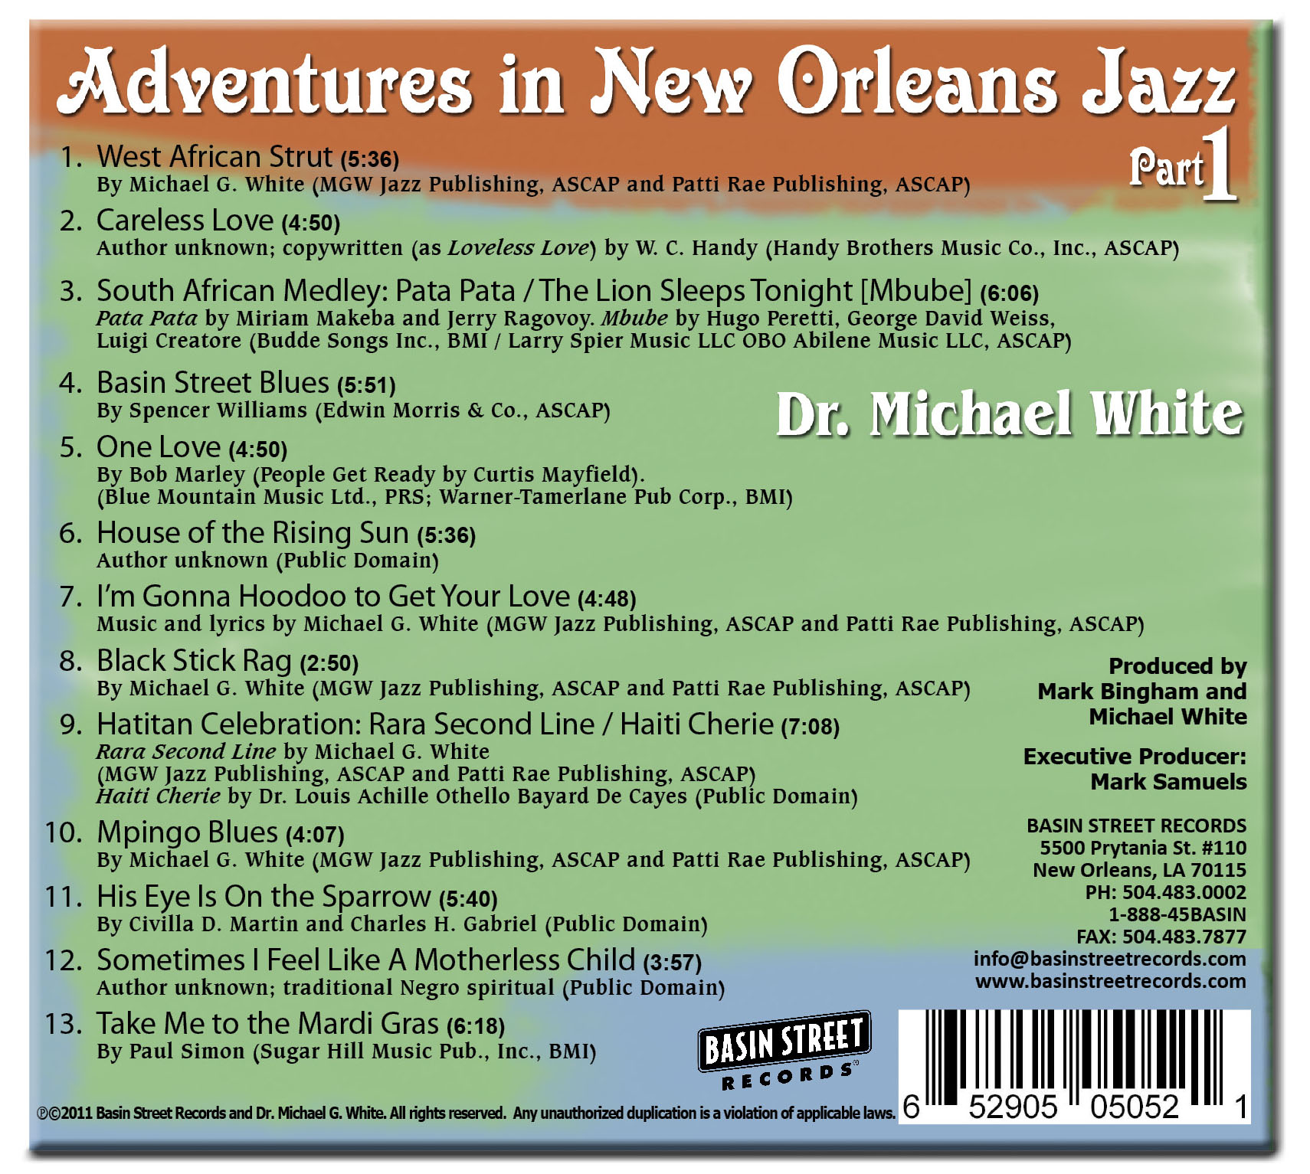

Sites that offer music for ‘free’ use as well as some music for license.

There are a number of sites that offer a combination of music for free use as well as works where one can pay a small fee.

1) Creative Commons is a site that has many layers. In addition to free music, it also provides licenses for specific music. The permission granted varies with the piece. In some cases, the use of a piece of music is completely free, with the only requirement being that the artist is acknowledged. In other cases, there might be a one-time fee for use, or that you ‘buy’ the piece and pay a small fee for each performance.
It is important to note that Creative Commons is a place where you can find free music, but that at times you will need to interact with the artist directly to determine use. It is not a search engine, and you should always verify that the work you are considering is actually under the CC (Creative Commons) license. If you have any doubt whatsoever, you should contact the copyright holder directly or contact the site where you found the content.

2)SoundFORMovement is a site where music by Michael Wall can be found. There is a free library, and for the other music arrangements a license can be made.

3)Free Music Archive- An interactive library of legal audio downloads. It is pre-cleared for certain types of uses and use is determined by the rights-holders themselves. On the main page itself, music can be searched by genre.

4) Amazon Music offers many free music downloads. There is a free music download section that is constantly being updated.

5) SoundCloud offers a free music download collection. It is basically a free streaming service, but many artists allow free downloads as well. Some artists only stream due to their contracts with major recording labels. There is not a dedicated free music download section so one will need to take the time to search.

6) Jamendo Music offers downloads that are completely free and protected by Creative Commons licenses. Basically, this means that the creators of the music don’t mind if you download their music for personal enjoyment. If you plan to use it for other purposes, you can contact the artist for a license to use. Since these artists are with Creative Commons, there will be a variety of arrangements that can be made.

7) PML-Production Music Libraries provide an inexpensive method of obtaining rights for original music and sound effects on a nonexclusive basis. PML music is usually instrumental and is used for film, websites, slide shows, etc. It is similar to stock photography and is categorized by genre or mood. Music from these sites are sometimes sold in a CD collection on a royalty-free, blanket fee, or a per-use fee basis. It is best to thoroughly explore the site from which you get the music to see if you are getting a shortened version or the full-length version of each composition.
Some examples of Production Music Libraries are:
MarmosetMusic
Audioblocks
Firstcom
Soundstripe
Universal Production Music

SYNCHRONIZATION RIGHTS refer to the right to use a piece of music as a soundtrack with images. It is the right to use music in timed relations with elements in a film, video, television show, commercial, or other audio-visual production. Music Publishers issue licenses as copyright owner or his agent, usually to a producer, granting the right to synchronize the musical composition in timed relation with audio-visual images on film or video.

DERIVATIVE RIGHTS refer to the legal permission to develop a new work derived from an original work protected under copyright law.

Under the Copyright Act, a "'derivative work' is a work based upon one or more preexisting works, such as a translation, musical arrangement, dramatization, fictionalization, motion picture version, sound recording, art reproduction, abridgment, condensation, or any other form in which a work may be transformed.

FAIR USE- Because there are so many grey areas, assume that nothing is fair use. According to Richard Stim, the author of Getting Permission, ‘fair use’ is any copying of copyrighted material done for a limited and ‘transformative’ purpose, such as to comment upon, criticize or parody a copyrighted work. Overall fair use of copyrighted material can be under the umbrellas of educational use, not for profit use, transformative use, and parody.

Examples of Fair Use for Music:
1) Using 3 seconds of a song
2) Doing a parody of a song using a play on words for a song like “I Got Rhythm” and transforming it to “I’ve Got Chicken”, using only the first four notes of the song and then a completely different melody thereafter.

Overall, the only way to get a definitive answer on whether a particular use is ‘fair’ is to have it resolved in federal court. In this case, the four factors judges consider are:
* the purpose and character of your use
*The nature of the copyrighted work
* the amount and substantiality of the portion taken
* the effect of the use upon the potential market

The idea to keep in mind is that there is very little material that is used that would count as ‘fair use’. There is no guarantee that how you are using material will count as fair use. Play it safe and get permission.

