**OHIO STATE DANCE EXTERNAL HARD DRIVE GUIDE**

At Ohio State Dance, technology is deeply embedded in the curriculum, so all dance majors are **required** to have a hard drive fast enough to act as a media drive. It’s crucial that your external hard drive meets these tech specifications:

* HDD (Hard Disc Drive) 7500 or SSD 1050 or higher transfer speed (Solid State Drive)
* At least 1TB storage
* USB 3.0 connection

These specifications ensure you will not only have enough storage but also enough power to work effectively. After you buy the drive, it needs to be formatted for Mac (Department computers are entirely Mac, include the Dance Media Lab SU343). All externals hard drives can only be formatted for Mac **or** PC (not both) so if your personal computer is a PC/you have outside courses in a PC lab/etc., you may need an additional hard drive. See follwoing pages for how to format your external hard drive on Mac.

The brand of hard drive is up to you but below are some suggestions (links may not have the best price, use your preferred search engine to find best deal).

* [Samsung 1TB T7 Shield Portable SSD](https://www.bhphotovideo.com/c/product/1691588-REG/samsung_mu_pe1t0s_am_1tb_t7_shield_portable.html/reviews)
* [Crucial 1TB X10 Pro USB 3.2 Gen 2x2 Portable SSD](https://www.bhphotovideo.com/c/product/1776923-REG/crucial_ct1000x10prossd9_1tb_x10_pro_usb.html/reviews)
* [SanDisk Professional 1TB G-DRIVE ArmorATD USB-C 3.2 Gen 1 External Hard Drive](https://www.bhphotovideo.com/c/product/1774937-REG/sandisk_professional_sdph81g_001t_gba1d_g_drive_armoratd_1tb_usb_c_3_1.html)

**Please note that a flash/thumb drive is not an acceptable substitution.

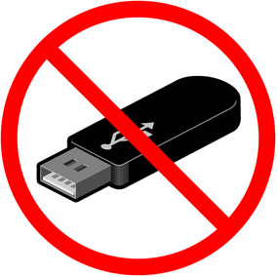

**HOW TO FORMAT YOUR HARD DRIVE**

For more external drives, they can be formatted for either a PC or a Mac. When you first get your hard drive, it needs to be formatted for the type of computer you will be using it on. Note: formatting will erase everything on the drive.

* Connect your hard drive to a Mac
* Go to the Utilities Folder (in the Applications Folder). Launch the program there called Disk Utility. You can also click the magnifying glass in the menu bar and search for the app there.
* You’ll see your hard drive in the sidebar window on the left. Single-click to select it.

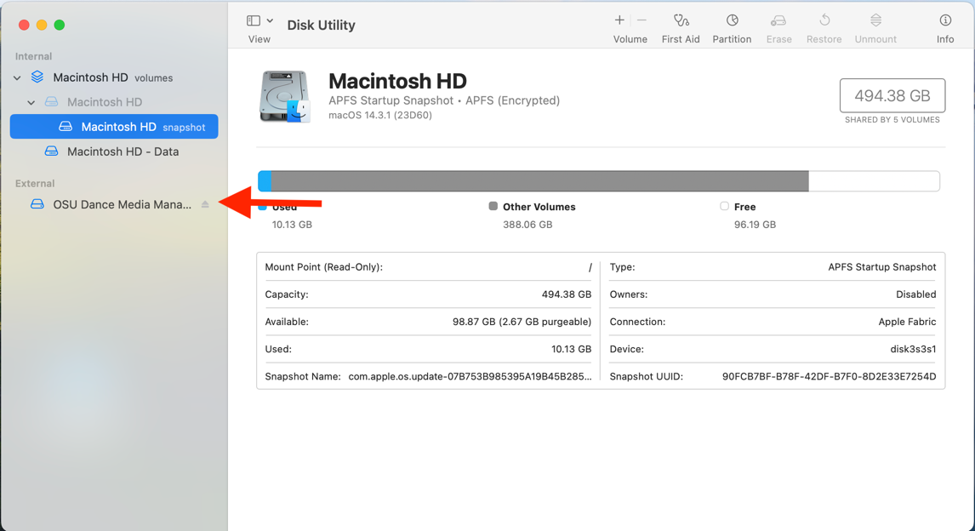

* Click the ERASE menu button at the top

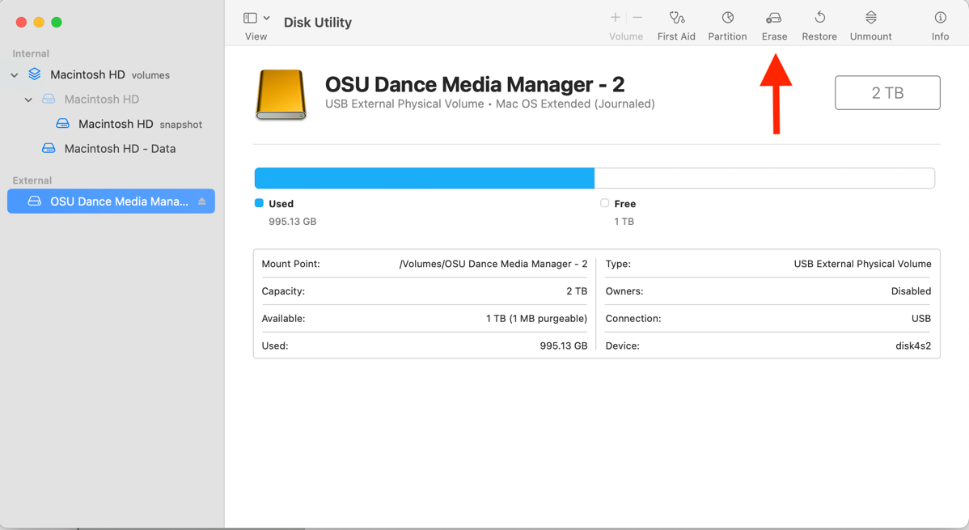

* Choose a name for your drive

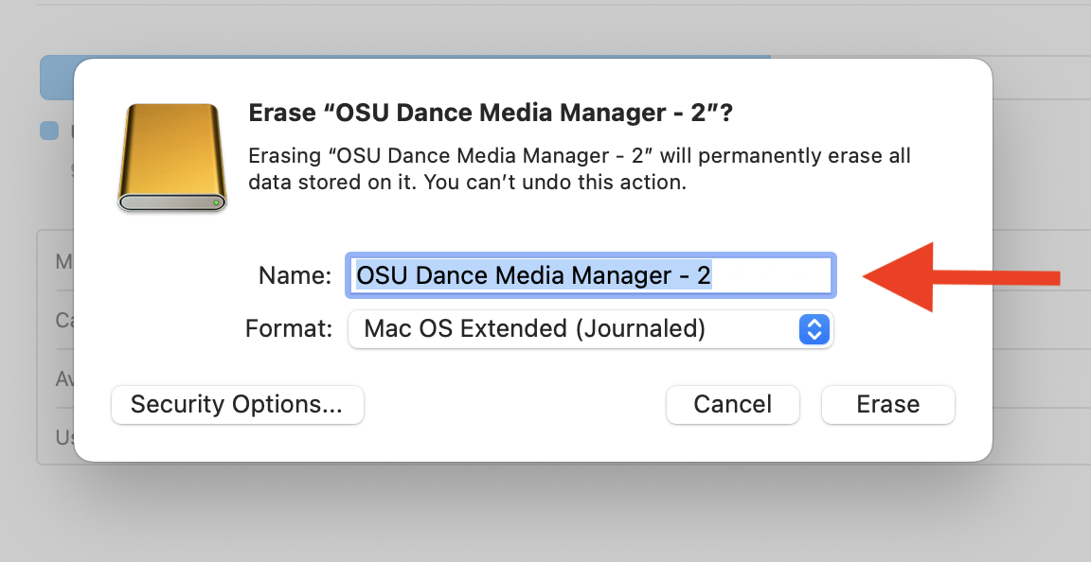

* From the FORMAT menu select: MAC OS EXTENDED—JOURNALED)

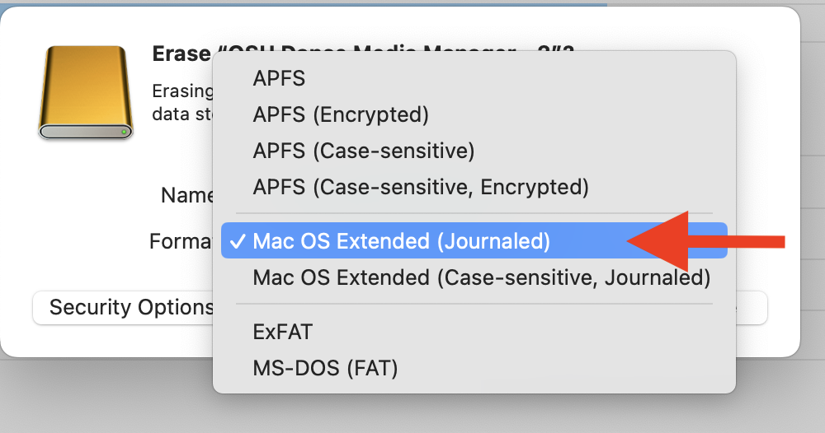

* Click the ERASE button at the bottom.

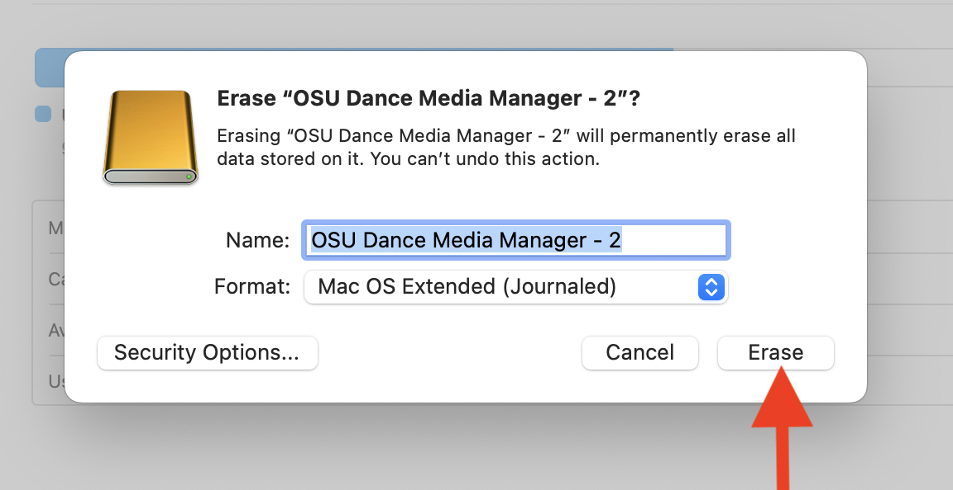

* Done! Now your hard drive is ready to use 😊

**\*\*\*REMEMBER: Always safely eject your hard drive before unplugging it. Unplugging a hard without ejecting can damage the files on it. Recovering damaged files via a data recovery service can run you $500+ so make sure to safely eject each time!**